Cubic shape vacuum packaging machine——large package LZB-150-M3/S
◉Applications
Suitable for brick-shaped vacuum quantitative packaging of granules in refined rice, food, grains, sugar and other industries.
◉Technical Parameters
Model | LZB-150-M3/S
Weighing Extent(kg) | 10~25（cashew）
Operation Speed (bags/h) | 140-160
Accuracy Grade | X(0.5)
Power, Power Consumption | AC 380V 50Hz、5KW
Air, air expenditure | 0.4~0.6MPa 20m³/h
Dimensions (L × W × H mm) | 2950×1380×3000

◉Main configures
NO. | Name | Suppliers
1 | Touch Screen | Japan/Omron
2 | Weighing Controller | Canada/General measure
3 | PLC | Japan/Omron
4 | Power Supply | Japan/Omron
5 | Solid State relay | Japan/Omron
6 | Intermediate relay | Japan/Omron
7 | Load cell | China/Zemic
8 | phase order protector | France/Schneider
9 | Vacuum pump | JiangSu/Raffles
10 | Cylinder | Taiwan/AirTAC
11 | solenoid valve | Taiwan/AirTAC
12 | solenoid valve | Taiwan/ABBA
13 | reduction drive | Taibang
14 | servo motor | Shenzhen/Huichuan
◉Functions and Features
- Suitable for the cubic shape vacuum packaging of cashew nut, peanut kernel, grain and other industries.
- Gravity feeding and vibration feeding to ensure material particle integrity and stable performance.
- The use of bucket measurement, high measurement accuracy, fast weighing speed.
- The two-sided vacuum bag replaces the traditional organ bag for six-sided vacuum packaging, which greatly reduces the packaging cost.
- Adopt Omron touch screen, Omron PLC centralized control, intelligent control weighing, filling, six-sided shaping, Vacuum, heat sealing, unloading, conveying the whole process, real-time tracking system status, man-machine interface friendly, easy to operate.
- Mold replacement, simple and convenient.
- The operation space is reasonable, and the right discharge conveyor realizes seamless docking with the subsequent conveyor belt.

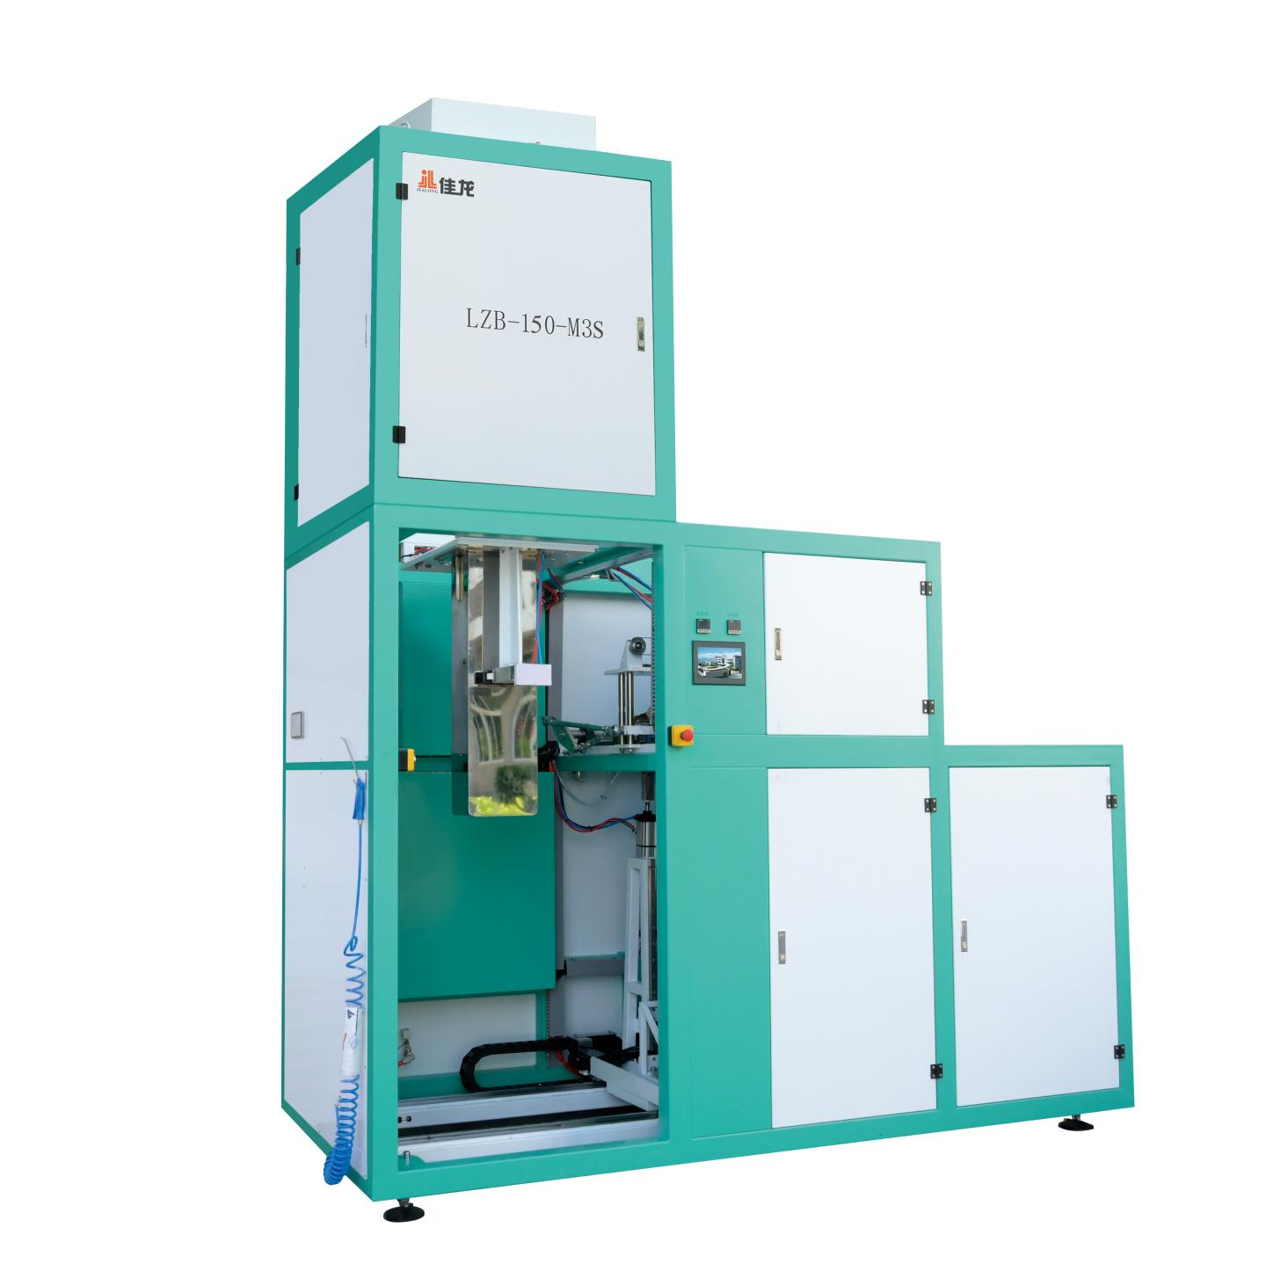
◉Equipment dimensions drawing

◉Adaptive packing range
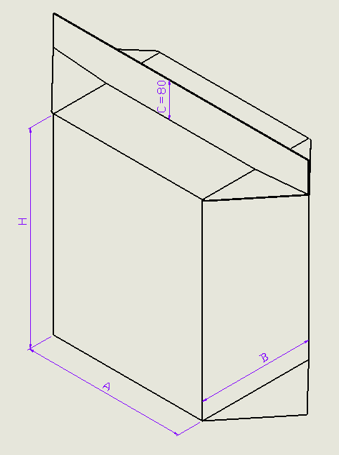
Molding size packaging range (mm)
Height：280≤H≤550
Width：200≤A≤340
Thickness：140≤B≤240

